Nanyang Technological University

School of Computer Science and Engineering



Laboratory Report

CZ2003

Computer Graphics and Visualization

Lab 4

Nintendo Switch Object using Implicit Solids

By

Teo Wei Jie (U1822263C), SS2

24 April 2020

Contents

1 Introduction 1

Note 1 2

2 Left Joy-Con Shape Creation 3

2A Diffused Colour 3

2B Base Plane 3

2C Base Solid 4

2D Circle Pad Base 5

2E Circle Pad 7

2F Round Buttons 8

2G Miscellaneous Buttons 9

2H Back Button 10

2J Top Button 11

2K Unionising Individual Shapes 12

3 Right Joy-Con 12

4 Screen 13

4A Additional Details 14

5 Conclusion 14

# 1 Introduction

|  |  |
| --- | --- |
| Figure 1 – Front View | Figure 2 – Back View |
| Figure 1 – Front View | Figure 2 – Back View |

A shape comprising of implicit solids, inspired by the “Nintendo Switch Joy-Con”, is created for the compulsory portion of this lab (Figures 1 and 2).

The above shape is defined in “Lab4_Joycon_Only.wrl”.

|  |  |
| --- | --- |
| Figure 3 – Screen | Figure 4 – Right Joy-con |
| Figure 3 – Screen | Figure 4 – Right Joy-con |

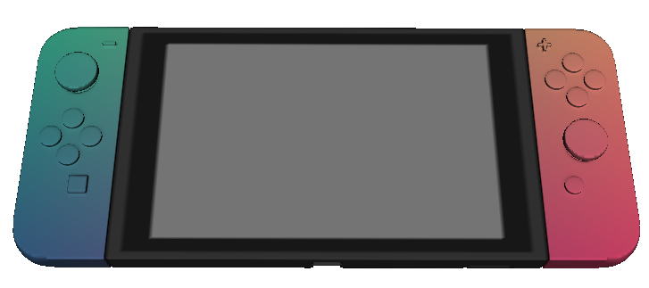

Figure 5 – Nintendo Switch comprising of multiple transforms/shapes

Two additional shapes are also included as part of the optional portion of this lab, namely the “Screen” (Figure 3) and the “Right Joy-con” (Figure 4). Each shape is wrapped separately in a Transform object such that the shapes may be translated along the X-axis. The “Left Joy-con” (Figure 1) is translated to X = -1.4 while the “Right Joy-con” (Figure 4) is translated to X = 1.4 to form the Nintendo Switch (Figure 5).

The Nintendo Switch is defined in “Lab4.wrl” which contains the individual shape definitions for the right joy-con and the screen as well.

Note 1: When running “Lab4.wrl”, the screen is rendered first before the two joy-cons due to the simplicity of the shape. The two joy-cons will render after about 3 seconds. The individual shape in “Lab4_Joycon_Only.wrl” renders after about 3 seconds as well, which fulfils the requirement of rendering below 5 seconds.

# 2 Left Joy-Con Shape Creation

The joy-con is created using one FShape with multiple solids defined implicitly in its geometry. This section briefly describes how individual solids are created and unionised or intersected (min/max) to form the joy-con.

Variables defined in the VRML files are provided as references for each solid. Reproduction of the individual solids may be achieved by inserting a “return [variable_name]” call right after the variable declaration or assignment in the VRML file.

The FShape is defined with a resolution of 100 and with a bounding box size of 0.6, 1.45, 0.6.

## 2A Diffused Colour

The material of the joy-con is defined using a FMaterial with the following formula:

* r = (u+1.25)/5
* g = (v+2.5)/5
* b = (w+2.5)/5

This gives the joy-con a colour gradient of teal (top) to blue (bottom).

## 2B Base Plane

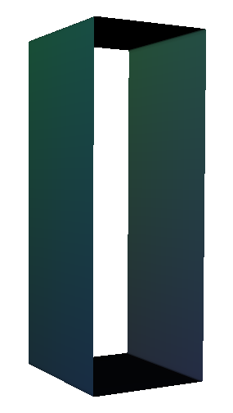

Figure 6 – Base Plane

A base plane is created that serves as the “foundation plane” used in most of the solids described in subsequent sections. Intersecting the base plane with two half-spaces bounded by different Z values creates a cuboid centred on different Z-coordinates, which may then be used to form the buttons and indentations on the joy-con.

The base plane is bounded by 4 intersecting half-spaces between -0.25 <= x <= 0.25 and

-0.7 <= y <= 0.7 and its corresponding variable name is “plane” (in “Lab4_Joycon_Only.wrl”).

## 2C Base Solid

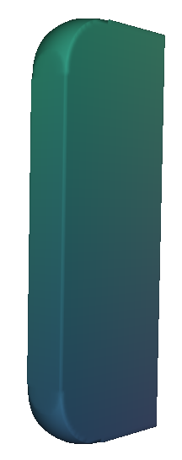

Figure 7 – Base solid of the shape

The base solid of the shape is a cuboid with two rounded edges (Figure 7). It is formed using the following solids:

|  |  |  |
| --- | --- | --- |
| Figure A |  | Cuboid using the intersection of the base plane and two half-spaces:  - min(plane, z + 0.08, 0.08 – z)  Variable name: surface |
| Figure B |  | Two ellipsoids using the following formulas:  - 0.2^2 - (x + 0.06)^2 - (y - 0.51)^2 - z^2  - 0.2^2 - (x + 0.06)^2 - (y + 0.51)^2 - z^2  Variable name: edgeEllipsoid |
| Figure C |  | Intersecting Figures A and B.  Variable name: edge1 & edge2 |
| Figure D |  | Union of two cuboids:  - min(x + 0.05, 0.25 – x, y + 0.7, 0.7 – y, z + 0.08, 0.08 – z)  - min(x + 0.25, 0.25 – x, y + 0.5, 0.5 – y, z + 0.08, 0.08 – z)  Variable name: surface3 |
| Figure E |  | Intersecting Figure C (x2) with Figure D to obtain the base solid as illustrated in Figure 7.  Variable name: mainSurface1 |

## 2D Circle Pad Base

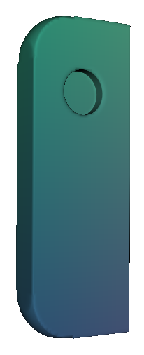

Figure 8 – Circle pad base indent (circled in red)

An indent is made on the base solid to form the base of the circle pad (Figure 8). The indent is made using the following solids:

|  |  |  |
| --- | --- | --- |
| Figure A |  | Cuboid using the intersection of the base plane and two half-spaces:  - min(plane, z - 0.02, 0.08 – z)  Variable name: indentSurface |
| Figure B |  | Cylinder using the following formula:  - 0.1^2 - x^2 - (y - 0.37)^2  Variable name: indentCylinder |
| Figure C |  | Intersecting Figures A and B.  Variable name: indent |
| Figure D |  | Taking the difference of the base solid and Figure C to obtain the solid as illustrated in Figure 8.  Variable name: mainSurface |

## 2E Circle Pad

|  |  |
| --- | --- |
| Figure 9 – Circle pad (circled in red) | Figure 10 – Solid attached to circle pad base |
| Figure 9 – Circle pad (circled in red) | Figure 10 – Solid attached to circle pad base |

The circle pad (circled in red in Figure 9) is created by attaching the following solids onto the circle pad base as illustrated in Figure 10:

|  |  |  |
| --- | --- | --- |
| Figure A |  | Intersection of a cuboid and ellipsoid:  - min(plane, z – 0.12, 0.16 – z)  - 0.12^2 - x^2 - (y - 0.37)^2 - (z - 0.13)^2  Variable name: circlePadSurface |
| Figure B |  | Cone using the following formula:  - min((z / 1)^2 - (x / 0.5)^2 - ((y - 0.37) / 0.5)^2, 0.12 - z, z)  Variable name: circlePadCone |
| Figure C |  | Unionising Figures A and B.  Variable name: circlePad |

## 2F Round Buttons

|  |  |
| --- | --- |
| Figure 11  – Round buttons circled in red | Figure 12  – Round buttons circled in red |
| Figures 11 and 12 – Round buttons circled in red | |

The round buttons (circled in red in Figures 11 and 12) are created using the following solids:

|  |  |  |
| --- | --- | --- |
| Figure A |  | Cuboid using the intersection of the base plane and two half-spaces:  - min(plane, z, 0.11 – z) [Figure 11]  - min(plane, z + 0.105, -z) [Figure 12]  Variable names:  - dPadSurface [Figure 11]  - buttonSurface [Figure 12] |
| Figure B |  | Cylinder using multiple formulas due to different X and Y positioning. The following formula is used for one of the buttons:  - 0.06^2 - x^2 - (y - 0.1)^2  Variable name: dPadCylinder |
| Figure C |  | Intersecting Figures A and B.  Variable names:  - dPad[Up/Down/Left/Right]  - unlockButton |

## 2G Miscellaneous Buttons

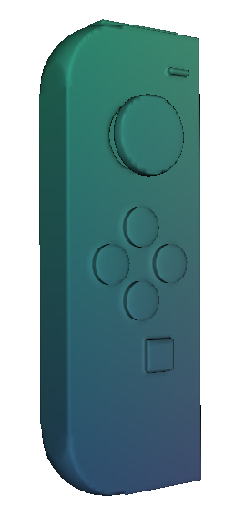

Figure 13 – Miscellaneous buttons (circled in red)

The miscellaneous buttons (circled in red in Figure 13) are created using the following solids:

|  |  |  |
| --- | --- | --- |
| Figure A |  | [Bottom square button]  Cuboid using the following formula:  - min(x - 0.02, 0.12 - x, y + 0.34, -0.24 - y, z, 0.105 – z)  Variable name: circleButton |
| Figure B |  | [Top “minus” button]  Cuboid using the following formula:  - min(x - 0.11, 0.19 - x, y - 0.57, 0.59 - y, z, 0.105 – z)  Variable name: minusButton |

## 2H Back Button

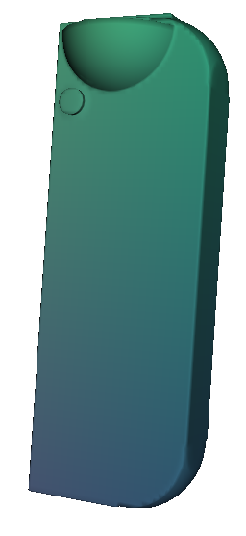

Figure 14 – Back button (circled in red)

The back button (circled in red in Figure 14) is created using the following solids:

|  |  |  |
| --- | --- | --- |
| Figure A |  | Cuboid using the following formula:  - min(x + 0.25, 0.25 - x, y, 0.67 - y,  z + 0.32, 0.04 - z)  Variable: backSurface |
| Figure B |  | Ellipsoid using the following formula, which is bounded by the bounding box:  - 0.2^2 - (x - 0.05)^2 - (y - 0.67)^2 - z^2  Variable name: backEllipsoid |
| Figure C |  | Intersection of Figures A and B.  Variable name: backButton |

## 2J Top Button

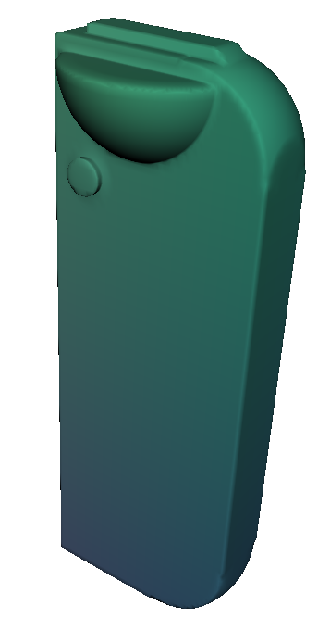

Figure 15 – Top button (circled in red)

The top button (circled in red in Figure 15) is created using the following solids:

|  |  |  |
| --- | --- | --- |
| Figure A |  | Cuboid using the following formula:  - min(x + 0.1, 0.2 - x, y, 0.72 - y, z + 0.04, 0.04 - z)  Variable: topButton |

## 2K Unionising Individual Shapes



Figure 16 – Joy-con shape by unionising different solids

The individual shapes defined in sections 2D to 2J are unionised to form the joy-con (Figure 16), with the corresponding variable name “controller” which is assigned a series of nested max functions:

- max(mainSurface, circlePad, dPadUp, dPadLeft, dPadRight, dPadDown, circleButton, minusButton, backButton, topButton, unlockButton)

# 3 Right Joy-Con

The right joy-con is defined the same way as the left joy-con with the only difference being the mirroring of the X axis values for certain solids, such as the ellipsoid for the rounded edge of the base solid.

The material of the joy-con is defined using a FMaterial with the following formula:

* r = (u+4)/5
* g = (v+2)/5
* b = (w+2)/5

This gives the joy-con a colour gradient of orange (top) to red (bottom).

The right joy-con is defined with a resolution of 100 and with a bounding box size of 0.6, 1.45, 0.6.

# 4 Screen

The screen is defined using a large cuboid of the following formula:

- min(x + 1.15, 1.15 - x, y + 0.7, 0.7 - y, z + 0.08, 0.08 – z)

The corresponding variable name for the cuboid is “surface” (in “Lab4.wrl”).

The colour of the screen is defined using an if-else clause in the FMaterial declaration of the shape as it is not bounded by the lab requirements:

if (z < 0.07) {

r = 0.2;

g = 0.2;

b = 0.2;

} else {

if ((abs(x) >= 1.07 || y >= 0.61 || y <= -0.66)) {

r = 0.2;

g = 0.2;

b = 0.2;

} else if ((abs(x) >= 0.92 || (y >= 0.53 || y <= -0.58))) {

r = 0.1;

g = 0.1;

b = 0.1;

} else {

r = 0.5;

g = 0.5;

b = 0.5;

}

}

## 4A Additional Details

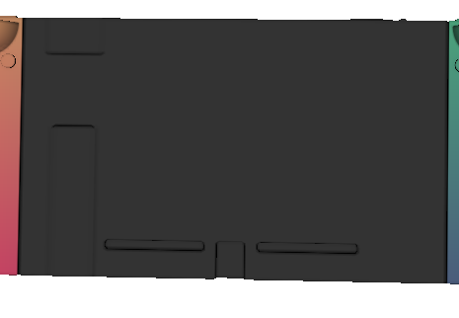

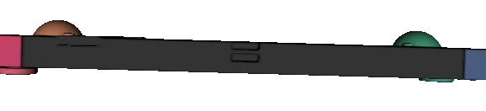

Figures 14, 15 and 16 – Indents (circled in red) and protrudes (circled in yellow)

The screen comprises several indents and protrusions that represent details such as the charging port, air-vents, speakers, and ear-jack port, power button, volume buttons, supporting stand and game card slot.

All indentations and protrusions are created using cuboids and performing difference or union with the screen cuboid.

# 5 Conclusion

A Nintendo Switch has been created using three different shapes for this lab. The left joy-con of the switch is made in accordance with the lab requirements as the compulsory part of the lab. The screen and right joy-con is defined separately as optional parts without conforming to the lab requirements. The three shapes are created using union, intersection and difference functions on various implicit solids, with each shape wrapped separately in a Transform object to perform translations along the X axis to form the Switch object as a whole.